Problem 1:

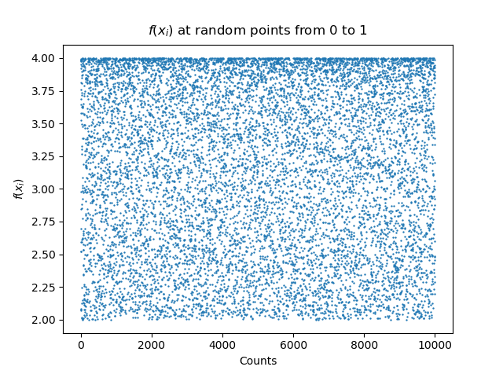
Compute the integral (1) again but this time uses the simple Monte Carlo method. Use 10,000 sampling points and plot a) f(xi) as a function of i from i = 1 to i = 10, 000, where xi is uniformly distributed over [0,1]:

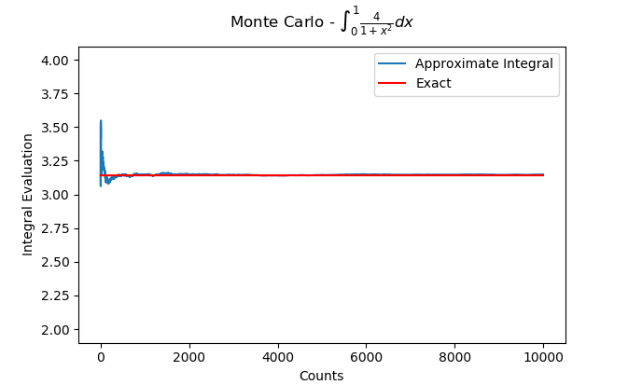
Plot also the running average f(xi) as a function of n and the line π:

By comparing the exact solution to the calculated solution as a function of N, the current number of trials ran, we can get a sense of how quickly the simulation approaches the theoretical value.
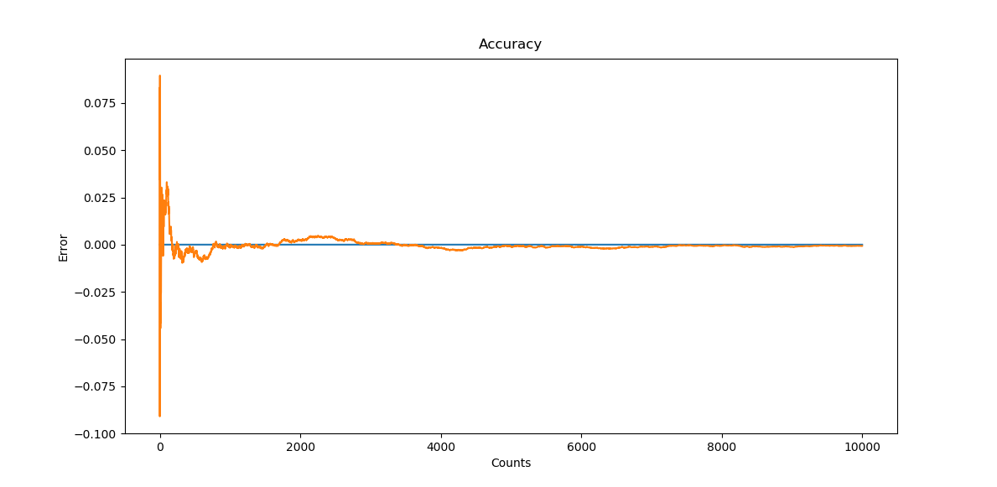
As can be seen here, it takes roughly 2500 trials for the algorithm to approach the theoretical solution.

Problem 4.

Same as number 3a, but using random variables weighted by P(x), we find:
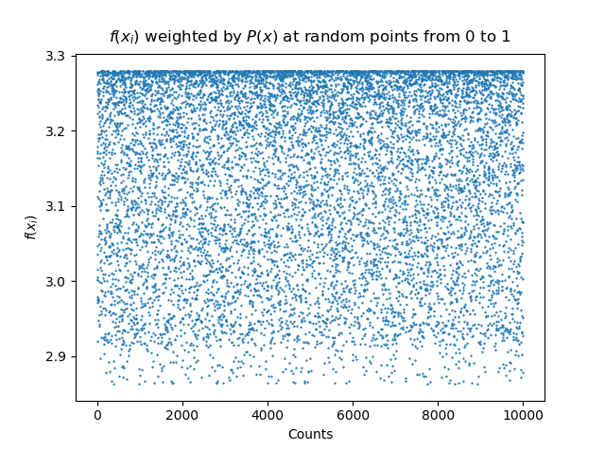
Plot also the running average f(xi) as a function of n and the line π:
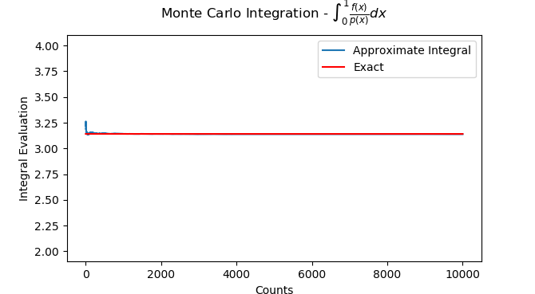
This simulation approaches the theoretical value so quickly, we can hardly tell a difference unless we zoom into the very beginning of the trials:

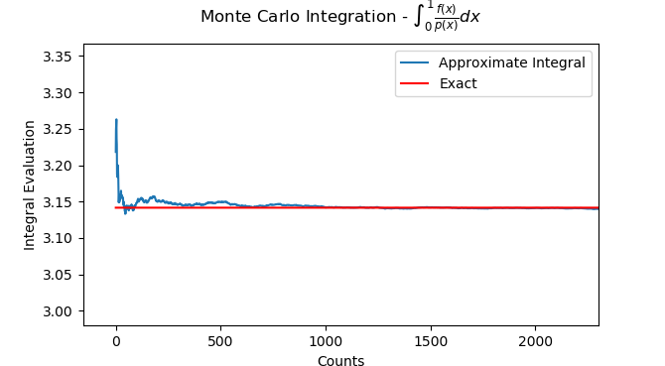
As can clearly be seen, the simulation approaches the theoretical value after only about 1000 trials.

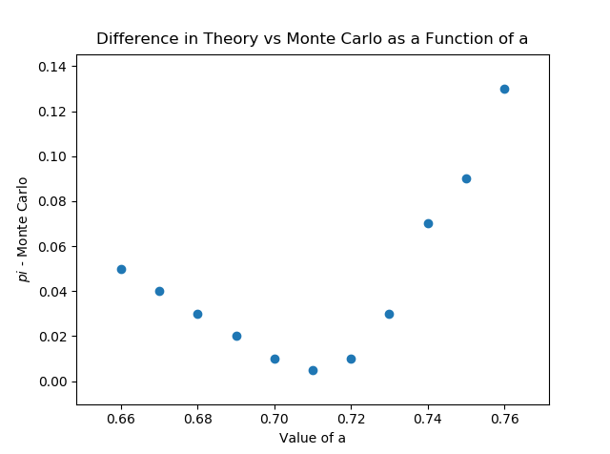
My value of 'a' was evaluated experimentally by comparing the long term accuracy of Monte Carlo runs as a function of 'a'. The above graph is using a value of a = .71

